***Lab 3:- Assignment 3:-***

***Source code:-***

#include <iostream>

#include <conio.h>

using namespace std;

void main(void)

{

int age;

cout<<"if you are 18 then you will be able to actived sim on your nic:"<<endl;

cin>>age;

if(age >= 18)

{

cout<<"your age is correct"<<endl;

}

Else

{

cout<<"your age is not correct"<<endl;

}

getch();

}

***Output:-***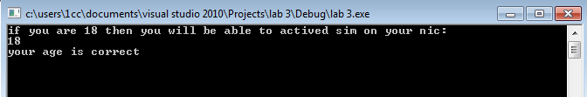

***Else:-***

